Databricks setup
Objective of Azure Databricks Setup
The objective of this setup is to create a cloud-based big data processing environment using Azure Databricks. It involves provisioning an Azure Databricks workspace and configuring a Spark cluster to enable scalable and distributed data processing. This setup allows users to execute PySpark code through notebooks, validate cluster functionality by running sample commands, and perform data engineering and ETL operations efficiently.
Databricks Setup Flow Diagram
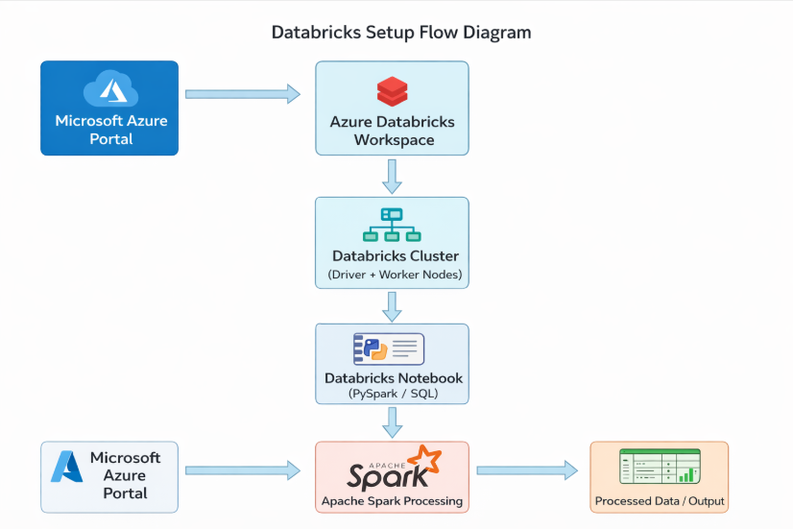
Step 1: Azure Portal Home
- Login to Microsoft Azure Portal
- Navigate to Azure Services
- Click on Azure Databricks

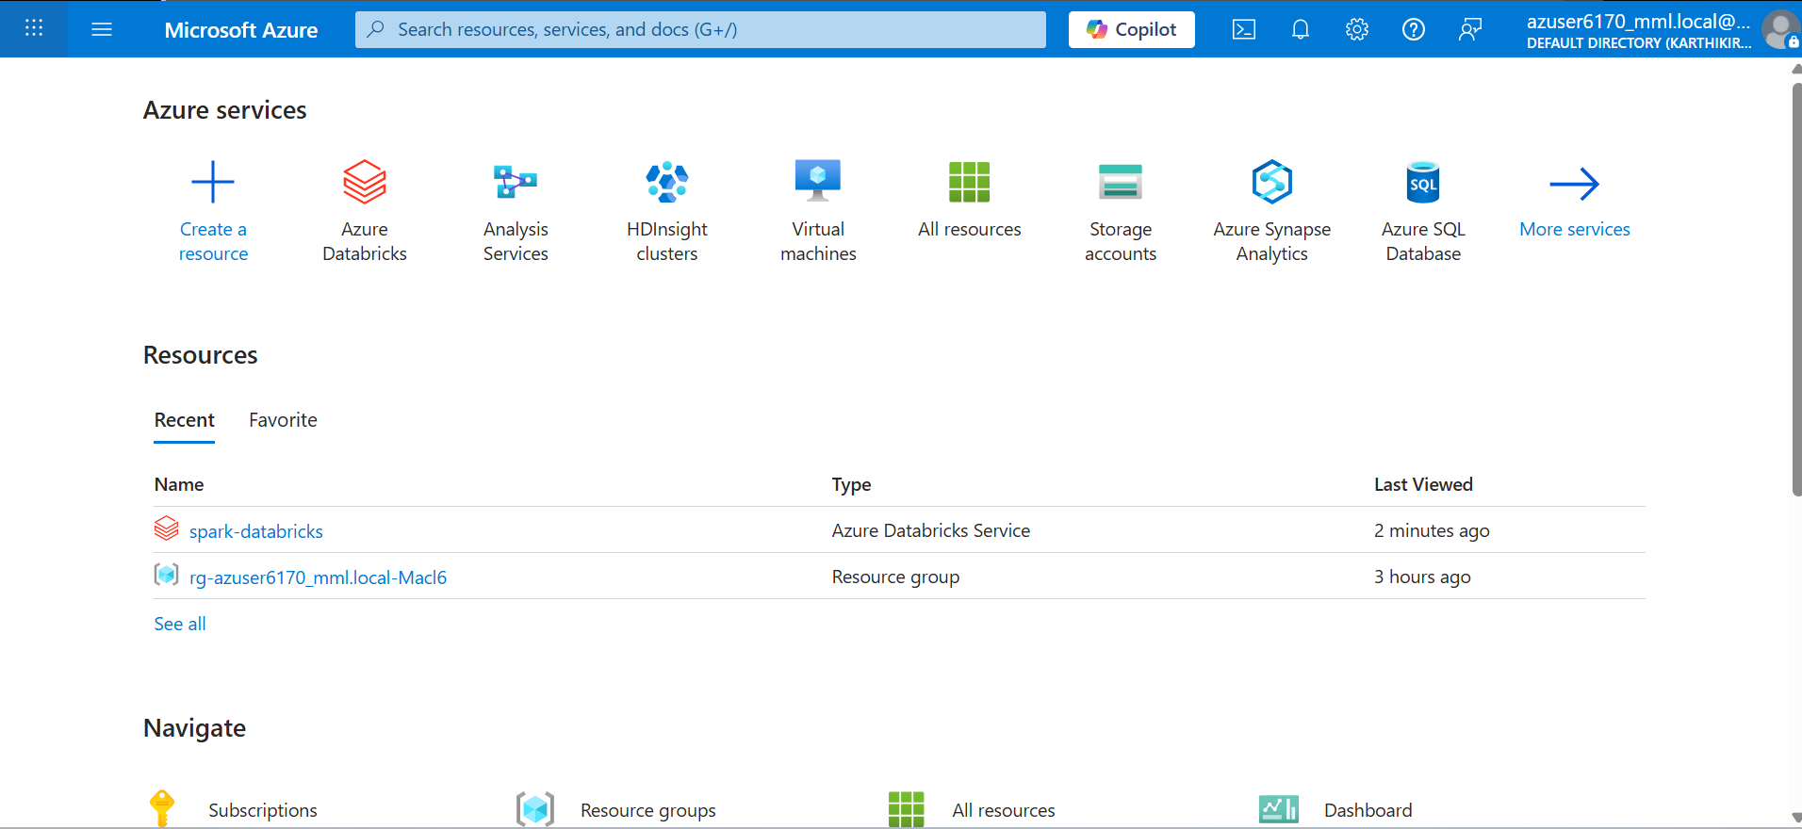
Step 2: Databricks Resource List
- View existing Databricks resources
- Click on your workspace (e.g., spark-databricks)
- Verify Resource Group and Subscription

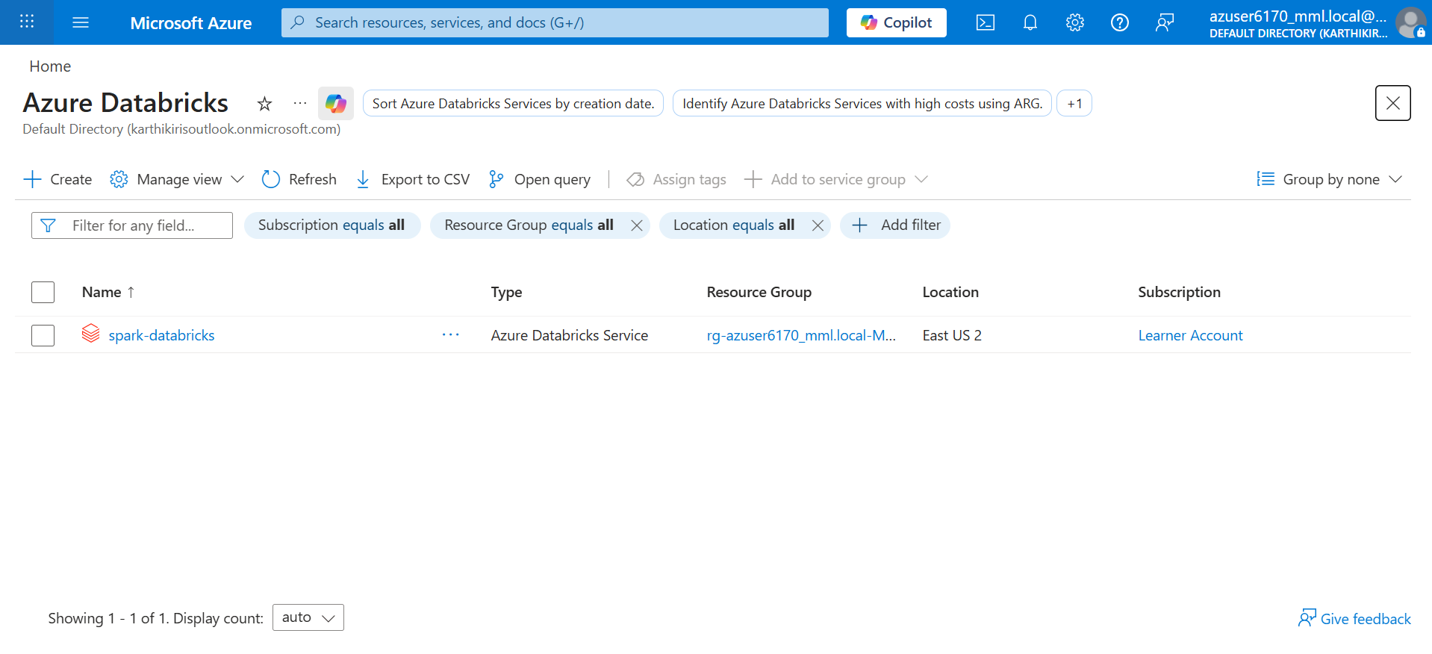
Step 3: Create Databricks Workspace – Basics
- Click Create Resource → Azure Databricks
- Fill the following:
  - Subscription: Learner Account
  - Resource Group: Select existing / Create new
  - Workspace Name: Enter name

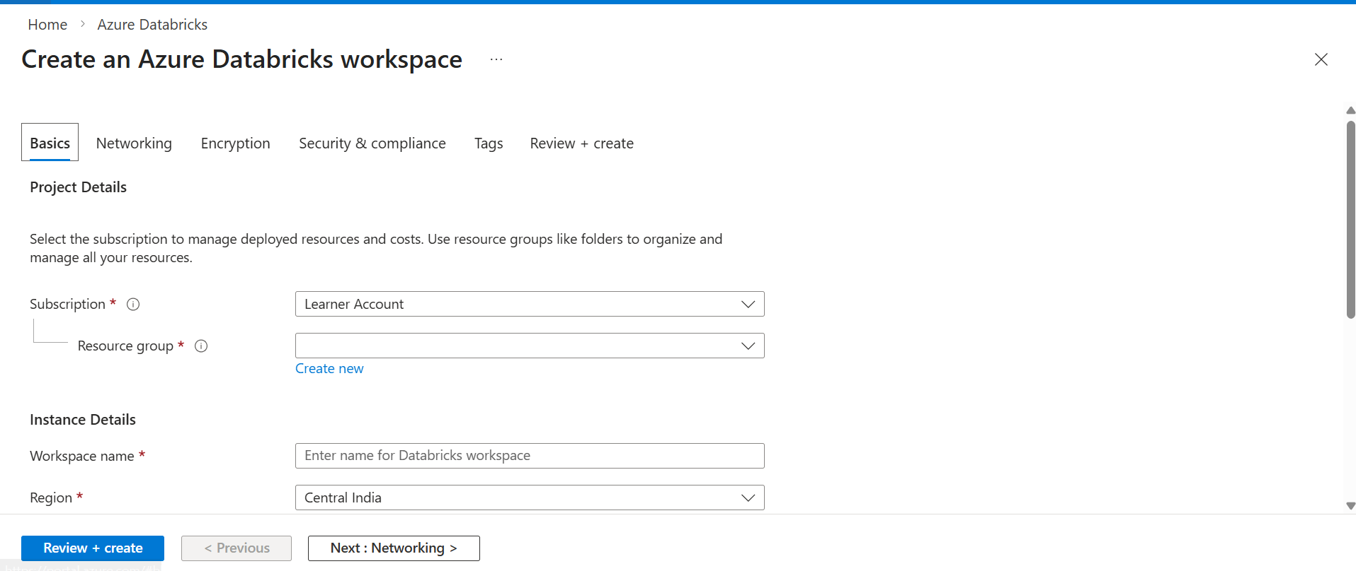

Step 4: Fill Workspace Details
- Provide required details:
  - Workspace Name: spark-cluster
  - Region: Central US
  - Pricing Tier: Standard
  - Workspace Type: Hybrid

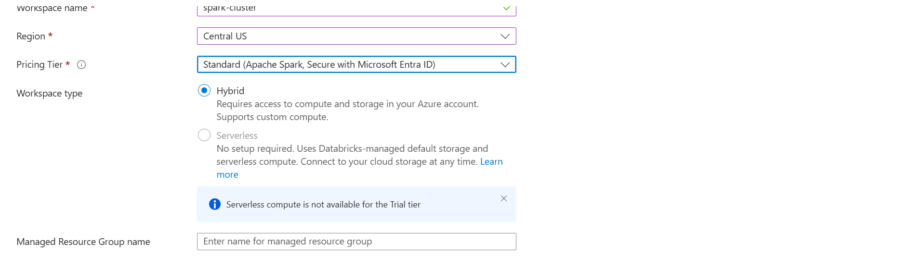
Step 5: Networking Configuration
- Configure networking settings:
  - Secure Cluster Connectivity: Yes
  - Virtual Network: No (default)
- Click Next

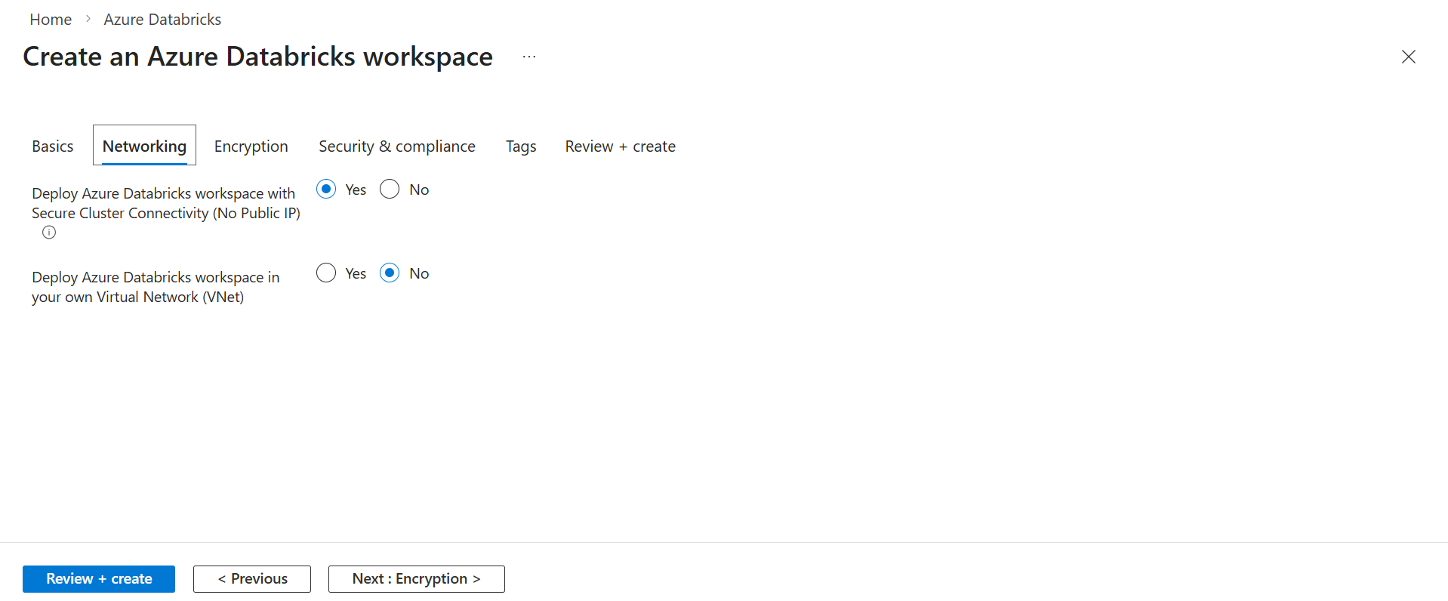

Step 6: Review and Create
- Review all configurations
- Validate settings
- Click Create

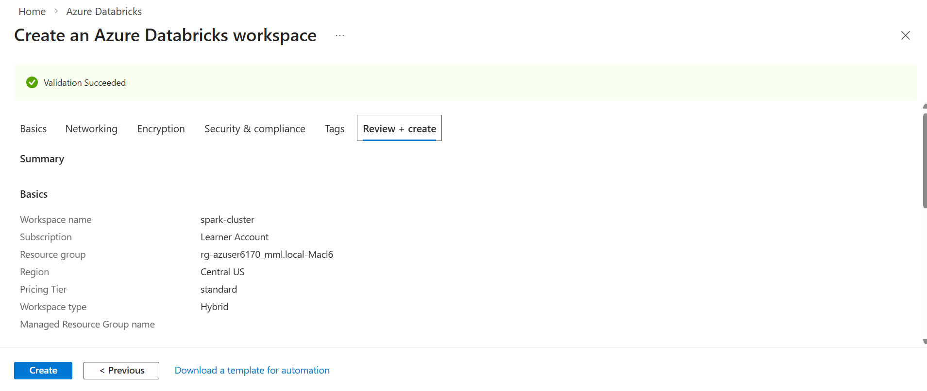
Step 7: Deployment in Progress
- Azure starts deployment
- Status shows: Deployment is in progress
- Wait for completion

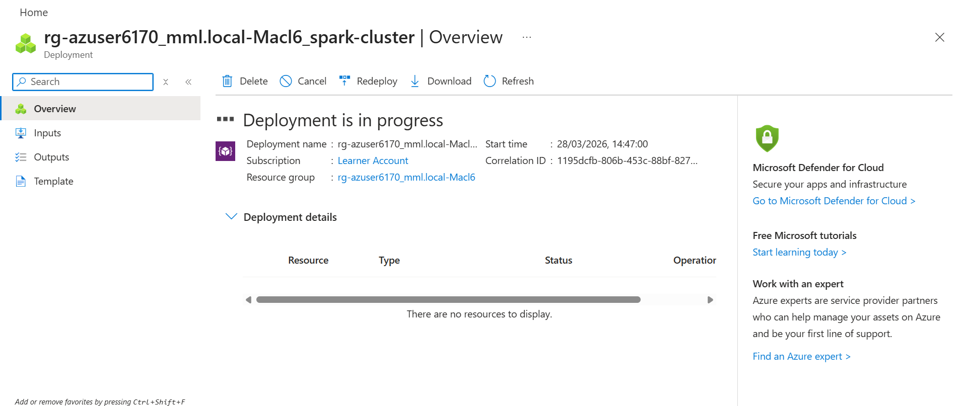

Step 8: Deployment Completed
- Deployment successful
- Click Go to Resource

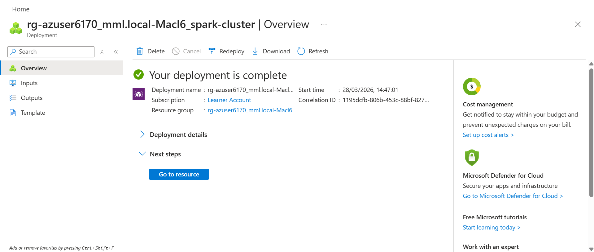
Step 9: Databricks Workspace Home
- Databricks workspace is launched
- You can see:
  - Workspace menu
  - Compute
  - Catalog
  - Jobs

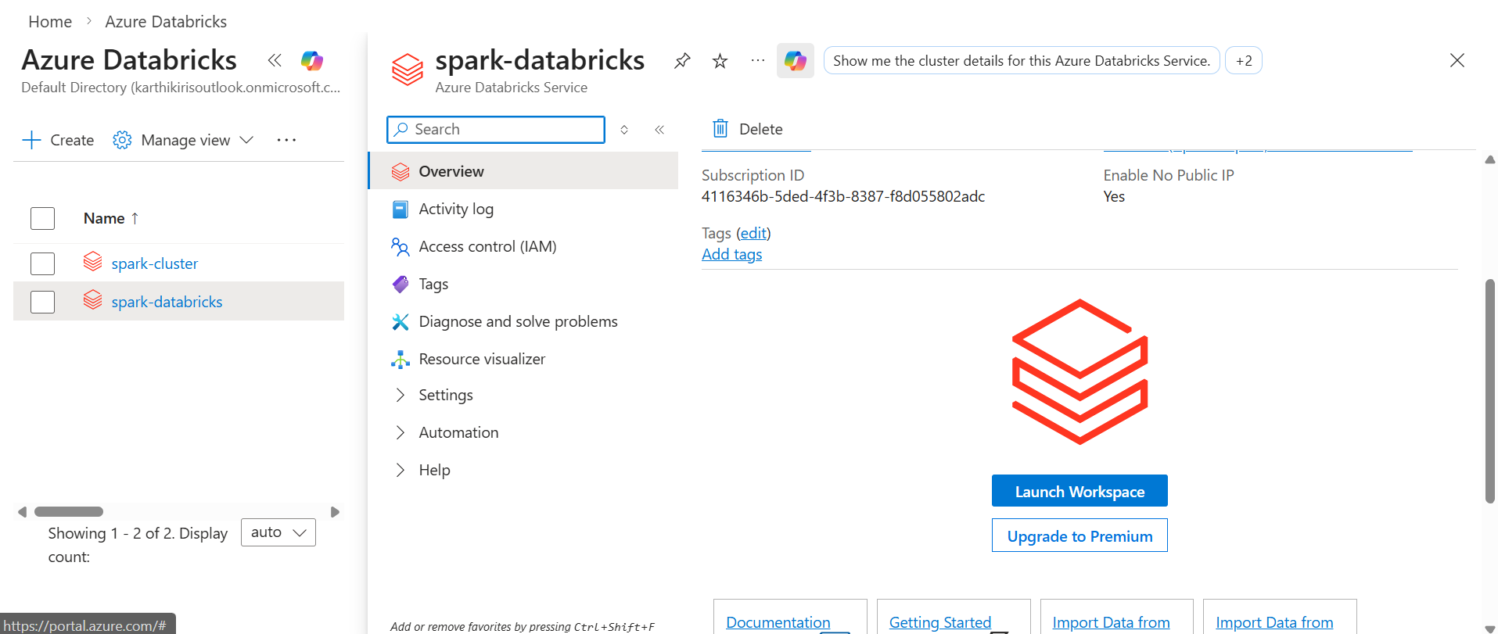

Step 10: Create Notebook in Databricks
After opening Databricks workspace, click on New
- From dropdown, select Notebook
- This option is used to create a new notebook where we write PySpark code

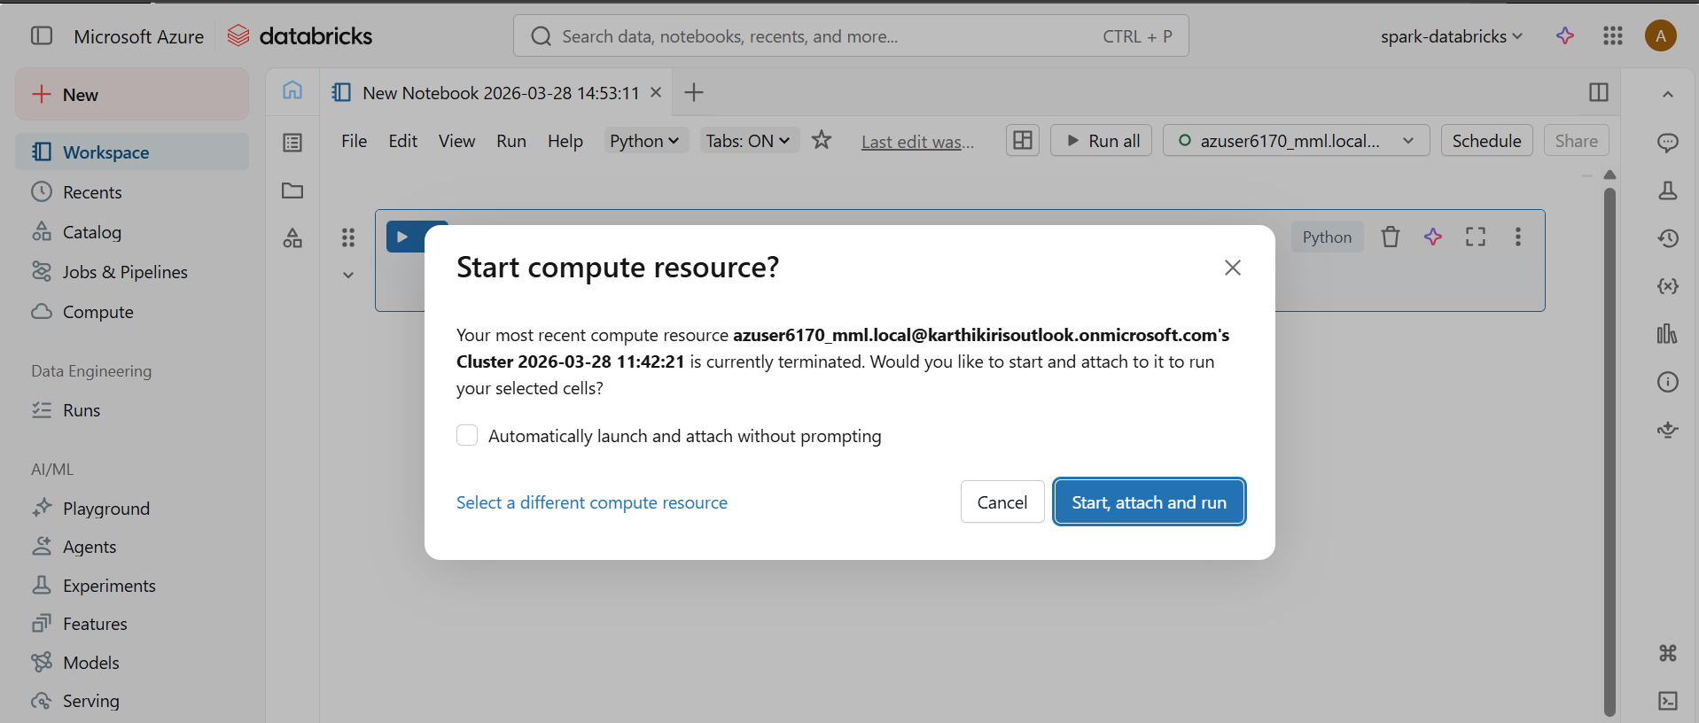
Step 11: Run Spark Code
- After cluster starts, notebook is connected
- Run the code:
spark.version
- Output displays Spark version (e.g., 4.0.0)
- This confirms Spark cluster is working successfully

